EXPERIMENT- 15
Perform Transformation using Direct Linear Transformation
Aim
To write a Python code to perform Direct Linear Transformation using OpenCV for mapping corresponding points between two images.
Input Images

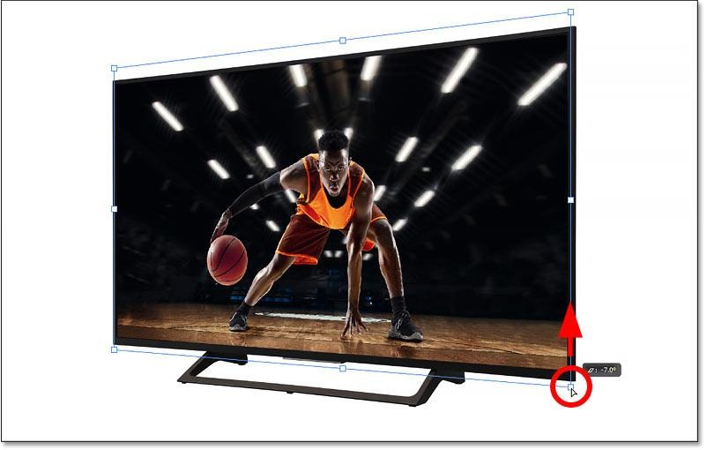
Code
import cv2
import numpy as np
from google.colab.patches import cv2_imshow
from google.colab import files
uploaded=files.upload()
paths=list(uploaded.keys())
img1=cv2.imread(paths[0])
img2=cv2.imread(paths[1])
if img1 is None or img2 is None:
print("Error: Image not found")
else:
pts1=np.array([[50,50],[200,50],[50,200],[200,200]])
pts2=np.array([[100,100],[300,100],[100,300],[300,300]])
H,_=cv2.findHomography(pts1,pts2)
dst=cv2.warpPerspective(img1,H,(img2.shape[1],img2.shape[0]))
print("Original Image")
cv2_imshow(img1)
print("Transformed Image")
cv2_imshow(dst)
Output Image
Transformed Image

Result
Thus, Direct Linear Transformation was successfully performed using OpenCV.

